IET.tv automation instruction manual

File Name | Version | Release Date
IET.tv automation instruction manual | 1.1

Revision History:

Ver. No. | Author | Approver | Release Date | Description of changes
1.1 | Babban Chandak/Amit Gajinkar |  | 15/01/2016 | Added configuration entries for Buy video, Buy channel, User generated content and Q&A modules

Table of Contents

1 Configuration File Details 3
2 Module Specific Configuration 6
3 System Specific Constraints 10
4 Module Specific Constraints 11
5 Issues 12

1 Configuration File Details

- Config.xml:
- Stores the details of all the modules needed to run test
- User can update config file as per requirement needed to run test

Example:
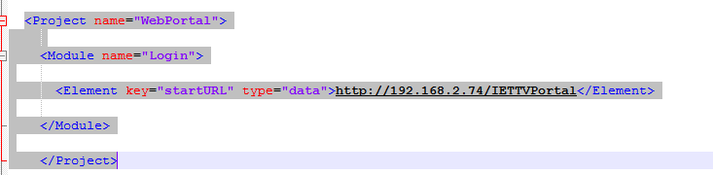
- Under ‘startURL’ key user need to update WebPortal Url

- SysConfig.xml:
- Global system setting details.
- User can update this file as per system setting that needs to be done.

Example:
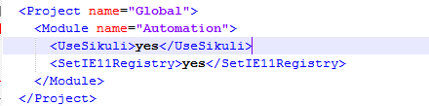

- Under ‘UseSikuli’ key user can update ‘yes’ or ‘no’ option to run sikuli or not

Note: In SysConfig.xml file if user keep key ‘UseSikuli’ value as ‘yes’ then at admin portal user authentication pop up will appear
If user keep key ‘UseSikuli’ value as ‘no’ then user who is logged into the system will automatically will logged into the IET.tv admin portal(Authentication pop will not appear)
Following one time setting needs to be done to disallow the admin authentication pop up at IET.tv admin portal

Steps :
1. Go to internet explorer – Internet option – Security-click on custom level

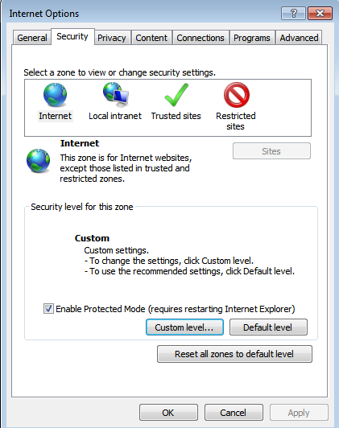

2. Setting – User Authentication – Logon – Select radio button “Automatic logon with current username and password”
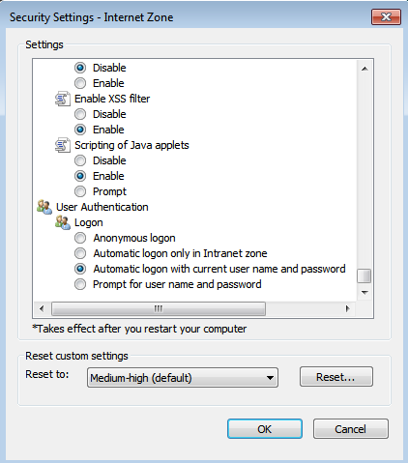

Module Specific Configuration
- Below is the screen shot of the Config.xml file:
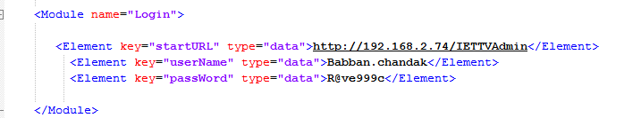

- Video management
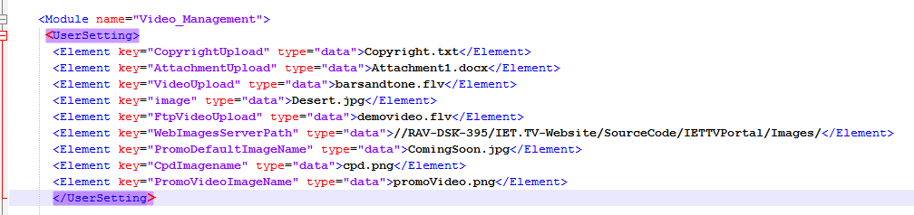

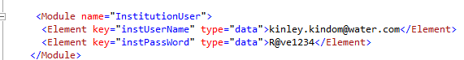

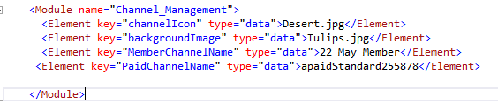

- Poll management
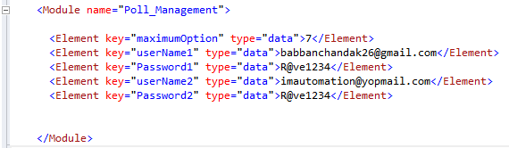

- Q&A Management
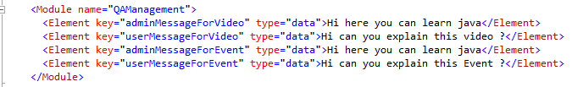

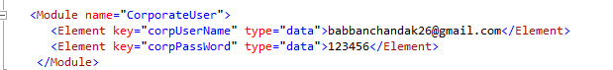

- Buy Video and Buy Channel
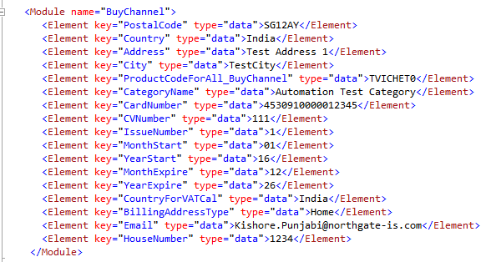

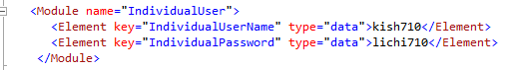

- List of all keys with its description:

Config.xml
Module Name | key | Description
Login | <Element key="startURL" type="data"> | Admin Portal Url
Login | <Element key="userName" type="data"> | Admin user name
Login | <Element key="passWord" type="data"> | Admin user password
Video Management | <Element key="CopyrightUpload" type="data"> | File name to upload copyright
Video Management | <Element key="AttachmentUpload" type="data"> | File name to upload attachment
Video Management | <Element key="VideoUpload" type="data"> | File name to upload video
Video Management | <Element key="image" type="data"> | File name to upload speaker
Video Management | <Element key="FtpVideoUpload" type="data"> | File name to upload video by ftp
Video Management | <Element key="WebImagesServerPath" type="data"> | Path where default images exist
Video Management | <Element key="PromoDefaultImageName" type="data"> | File name to select default promo image
Video Management | <Element key="CpdImagename" type="data"> | File name to upload cpd image
Video Management | <Element key="PromoVideoImageName" type="data"> | File name to upload promo video
Video Management | <Module name="InstitutionUser"> <Element key="instUserName" type="data">  <Element key="instPassWord"  type="data"> | User credentials required to like and dislike video
 | <Module name="Channel_Management">  <Elementkey="MemberChannelName"  <Element key="PaidChannelName" | Required to select channel from channel tab in Video management model
Poll Management | <Element key="userName1" type="data">  <Element key="Password1" type="data"> | First user credential for submitting poll
Poll Management | <Element key="userName2" type="data">  <Element key="Password2" type="data"> | Second user credential for submitting poll
Poll Management | <Element key="maximumOption" type="data"> | User can set maximum number of answers to a question for a poll
User Generated Content | <Module name="InstitutionUser"> <Element key="instUserName" type="data"> | User credentials required to Login
User Generated Content | <Modulename="Video_Management"> <Element key="VideoUpload" type="data"> | File name required to upload video
Q&A Management | <Element key=”adminMessageForVideo”  <Element key=”userMessageForVideo”  <Element key=”adminMessageForEvent”  <Element key=”userMessageForEvent” | Message content required for the conversation between user and admin
Q&A Management | <Module name=”CorporateUser”>  <Element key=”corpUserName”  <Element key=”corpPassWord” | User credentials required to perform Q&A to video
Buy Video and Buy Channel | <Module name="BuyChannel">  <Element key="PostalCode" type="data">  <Element key="Country" type="data">  <Element key="Address" type="data">  <Element key="City" type="data">  <Element key="ProductCodeForAll_BuyChannel" type="data">  <Element key="CategoryName" type="data">  <Element key="CardNumber" type="data">  <Element key="CVNumber" type="data">  <Element key="IssueNumber" type="data">  <Element key="MonthStart" type="data">  <Element key="YearStart" type="data">  <Element key="MonthExpire" type="data">  <Element key="YearExpire" type="data">  <Element key="CountryForVATCal" type="data">  <Element key="BillingAddressType" type="data">  <Element key="Email" type="data">  <Element key="HouseNumber" type="data">  </Module> | 1.Address and Net banking details required at the time of buying Video/Channel  2.Under key “CategoryName “ Category name required(Manually created) in order to create channel under it
Buy Video and Buy Channel | <Module name="IndividualUser">  <Element key="IndividualUserName" type="data">  <Element key="IndividualPassword" type="data"> | Individual user credentials required to buy Video/Channel
 | <Module name="DBConnection">  <Element key="Connectionstring" type="data"> | Required to connect database for assigning valid product code to the channel which we need to buy

NOTE:

            - If user wants to upload any other file other than files which are already present in ‘Upload’ folder path: C:\Project\IETTVWebPortal\Upload
Example: In Upload folder we have Video folder which contains video named as “barsandtone.flv”, if user wants to upload any other video (E.g.: video.mp4) then he needs to:
- Add that video in video folder
- Also needs to update config.xml file.(E.g.: For video user needs to replace key” VideoUpload” value from “barsandtone.flv” to “video.mp4”.)

- Need to create the procedure for product code insert regarding Buy Channel Module for the Environment of Automation Test Execution
- Here we are using Product code of Healthcare channel type Front

System Specific Constraints

- Sikuli – System needs to be in unlock state and current window should not be overlapped by any other window on which sikuli operation is getting performed
- Video recording(Evidence) - System needs to be in unlock state
- No interruption should be done once test execution started
- IET.tv Admin user credentials needs to be updated in config.xml file
- SmartBear scheduler – Scheduler Runs the test with delay of 8 to 10 minutes(As confirmed with smartbear team)
- While executing tests database record will get increase, because of which it might slow down the test execution – it is advisable to clean database (Manually) if number of records gets increase. (For the applicable modules only)
- The admin portal credentials should be unique for each host in the configuration file
- The maximum execution timeout in SmartBear is set to 25minutes.
- Currently configuration support only one SmartBear and multiple host but does not support multiple SmartBear and Multiple host
- All Test executed on the Operating system windows-7 in chrome browser
- Temp folder should be cleared at regular interval

Module Specific Constraints
- Video Management – We are waiting for max of 120 sec after clicking on publish button to get video to be published

Issues

Module | Issue | JIRA – SMARTBEAR ID | Impacted Tests
Poll Management | Search By dropdown has only four option when Video radio button is selected | TV-263 - 3346409 | None
Poll Management | Not able to see Poll panel on event landing page. | TV-264 - 3346408 | TVAdmin_003_PollManagementFuncForEvent,  TVAdmin_005_PollActivateInactivateForEvent,  TVAdmin_005_PollingDisplayFuncForEvent
Poll Management | Update functionality under Poll management is not working. | TV-265 - 3346407 | TVAdmin_004_PollActivateInactivateForVideo,  TVAdmin_005_PollActivateInactivateForEvent
Video Management | While Video Publish infinite Loading is seen -intermediate | TV-299 - 3368963 | Not specific to particular test

